**System Design and Architecture**

**Introduction:**

The objective of the Capstone project is to build reliable communication protocols like UART/I2C over FPGA board on Altera Cyclone II or Nexys4 DDR to easily interface sensors and different module to interface the Input and Output via FPGA boards using the unique features of the FPGA board. It will help the people to understand the FPGA and communication protocol structure and use of it while testing.

### **Project Proposal:**

A Field-Programmable Gate Array (FPGA) is a semiconductor device based on a matrix of configurable logic blocks (CLBs) connected via programmable interconnects. FPGAs are reconfigurable, meaning that the logic functions within the FPGA can be reprogrammed to implement different designs or algorithms after manufacturing. This reconfigurability contrasts with fixed-function Application-Specific Integrated Circuits (ASICs), making FPGAs highly versatile for prototyping and deployment in a wide range of applications.

The FPGA boards are quite faster than usual microcontroller because of its capability to adapt the advantage of different parameter like high speed parallel processing, custom GPIO interfaces, frequency trading, While FPGAs offer superior hardware-level performance and flexibility, microcontrollers are generally better for cost-sensitive or low-power applications with sequential tasks, thanks to their easier development process and lower unit cost.

Here we can use FPGA board of Altera Cyclone II or Xilinx Nexys 4 DDR, which are very well known FPGA Board for implementing Prototype of HDL design on it and test its compatibility for moving forward the Chip manufacturing or for making a design for an system in less time to build application with low cost.

**Altera Cyclone II with EP2C5T144 chip**

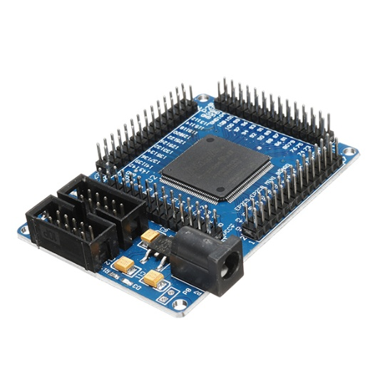

* EPROM chip configuration using EPCS4, the size of 4Mbit
* Onboard 50M active patch crystal (Crystal Slaughter halfback)
* Power supply with a largemouth outlet, single 5V power supply
* Board has power indicator and resets switch
* Onboard 3 SMD LED, the LED test can be done an experiment, more experiments using lead to complete

**Nexys 4 DDR with XC7A100TCS0324A**

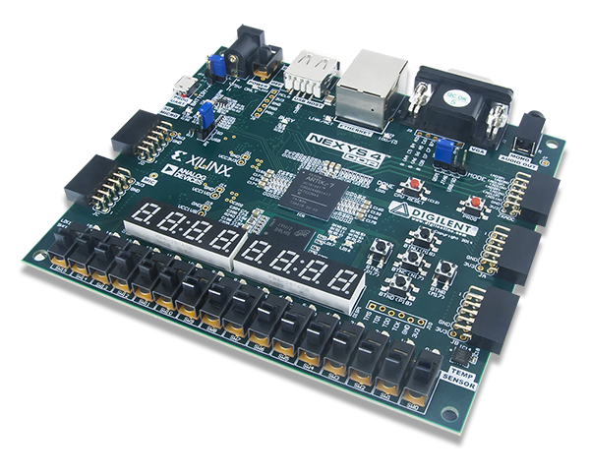 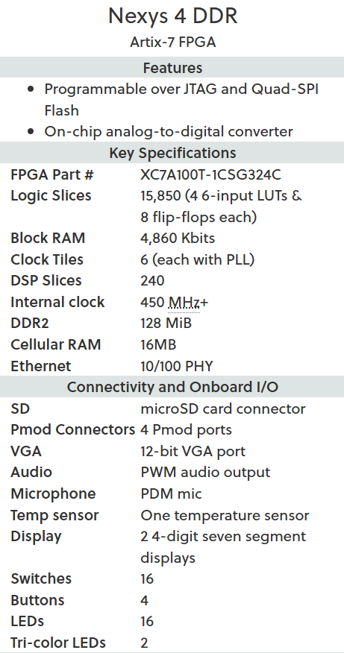

Flow Diagram for each communication protocols:

UART  
  
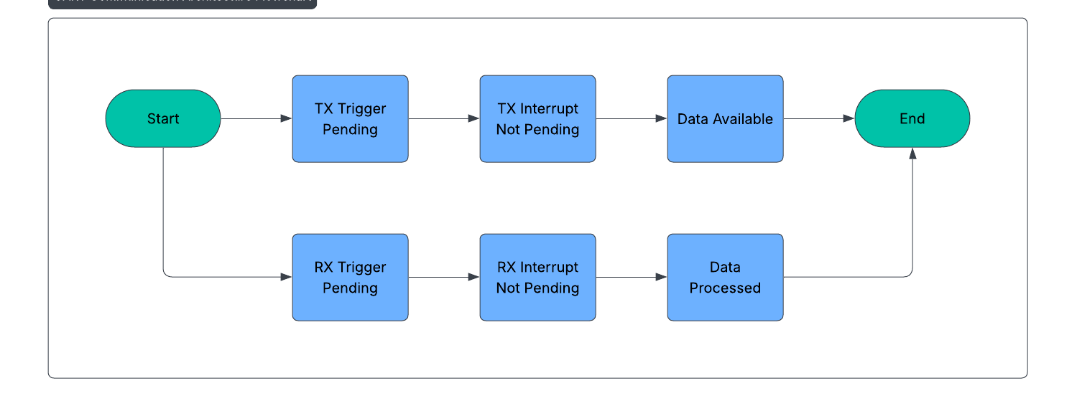

SPI

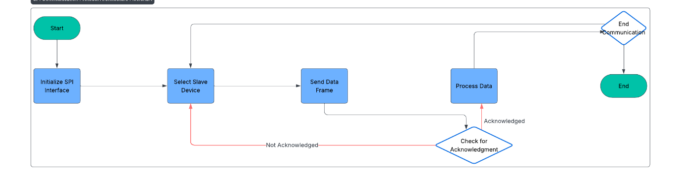

I2C

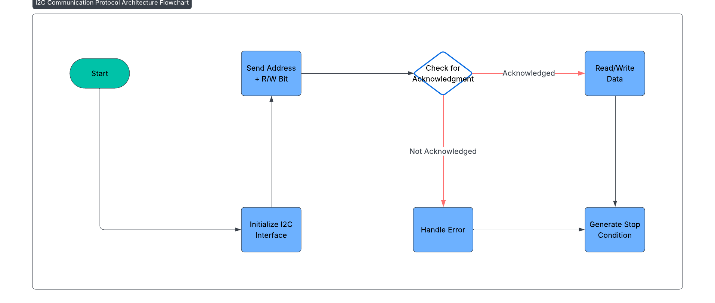

Modular Design:

Technology Stack:

Scalability Plan:

Conclusion:

**References:**